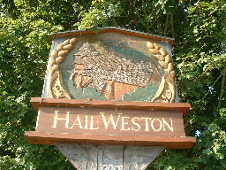

Hail Weston Parish Council invite all Residents to attend the

ANNUAL ‘PARISH ASSEMBLY’ OPEN MEETING

Hail Weston Village Hall

Tuesday 17th March 2026 at 7.30 pm

Meet your Parish Councillors
Hear about the Parish Council’s Work
Updates from village groups, & the Parish Council
Open Forum – tell us anything at all concerning your village

We hope to see you there

Refreshments will be offered at the meeting

